PSI Grant Submission Workflow

Introduction
We anticipate that PSI Investigators will wish to apply for external (and internal) research funding for projects, programmes, fellowships, studentships and equipment to enhance the success and development of individual groups and the PSI as a whole.
If you intend to apply for funding that is to be hosted in the PSI, then this needs to be reviewed and approved by PSI’s Institute Director. If necessary, the Institute Business manager will need to agree arrangements between PSI and host unit/departments.
This process is necessary to identify appropriate space provision and charging (new staff and equipment) between units and to ensure a triage process for strategic proposals with the highest relevance to PSI and avoid internal competition for funding.

Core and Affiliated PSI Investigators and research groups
Core –These are groups whose staff and students are supported and administered by the PSI professional services support team directly for operational needs. They are hosted in PSI space and their primary unit association is PSI. Currently this is limited to Horby and Gilbert groups.

Affiliated – These are groups whose staff and students are supported and administered by other units or departments but have a significant affiliation to the PSI. This will usually be due to their group leader being a member of the PSI Strategy Development Group or being appointed as a PSI investigator.
They are hosted in non-PSI space and their primary unit association is not-PSI.

Grant Application Workflow for Affiliated Groups & Investigators
Below is an overview of the workflow a PSI Affiliated Investigator (or an applicant from a PSI Affiliated group) should follow when they wish to apply for external or internal research grants funding with PSI as the lead department on the application, using their PSI affiliation.
Applications from PSI Core groups will by default be submitted via PSI.
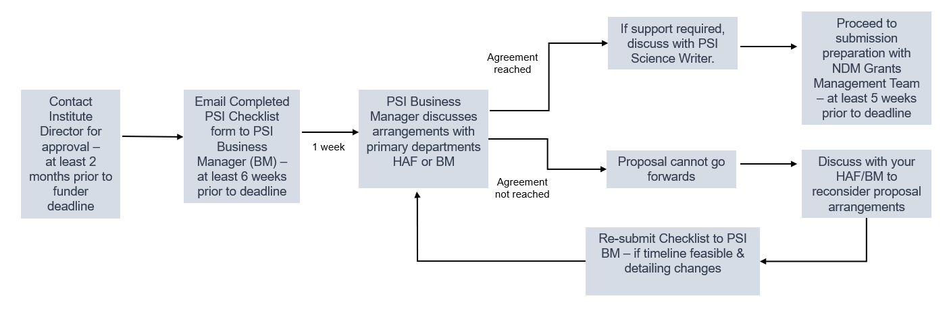
The PSI Checklist & PSI Science Writer Framework can be found here on the PSI internal webpages.

